Chapter 10

How to design a database

Exercises

1. Use MySQL Workbench to create an EER model from the script file named create_my_guitar_shop.sql.

From the model, create an EER diagram that shows the relationships between the seven tables in the database. (The administrators table is not related to the other six tables.)

1. Use MySQL Workbench to create an EER model for a database that stores information about the downloads that users make. (When you create the EER model, it will be given a default name of mydb. For this exercise, it’s not necessary to change this name.) Define the tables that are necessary to implement this data structure:

Each user must have an email address, first name, and last name.

Each user can have one or more downloads.

Each download must have a filename and download date/time.

Each product can be related to one or more downloads.

Each product must have a name.

When you’re done defining the tables, create a diagram for the database. Then, use the diagram to define the required relationships. When you do that, be sure to use the relationship button that uses existing columns.

Chapter 11

How to create databases, tables,   
and indexes

Exercises

1. Write a script that implements the following design in a database named my_web_db:

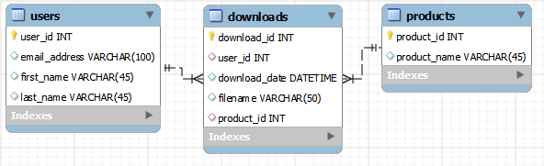

In the Downloads table, the user_id and product_id columns are the foreign keys.

Include a statement to drop the database if it already exists.

Include statements to create and select the database.

Include any indexes that you think are necessary.

Specify the utf8mb4 character set for all tables.

Specify the InnoDB storage engine for all tables.

1. Write a script that adds rows to the database that you created in exercise 1.

Add two rows to the Users and Products tables.

Add three rows to the Downloads table: one row for user 1 and product 2; one row for user 2 and product 1; and one row for user 2 and product 2. Use the NOW function to insert the current date and time into the download_date column.

Write a SELECT statement that joins the three tables and retrieves the data from these tables like this:

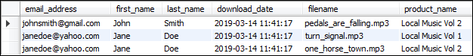

Sort the result set by the email address in descending sequence and the product name in ascending sequence.

1. Write an ALTER TABLE statement that adds two new columns to the Products table created in exercise 1.

Add one column for product price that provides for three digits to the left of the decimal point and two to the right. This column should have a default value of 9.99.

Add one column for the date and time that the product was added to the database.

1. Write an ALTER TABLE statement that modifies the Users table created in exercise 1 so the first_name column cannot store NULL values and can store a maximum of 20 characters.

Code an UPDATE statement that attempts to insert a NULL value into this column. It should fail due to the NOT NULL constraint.

Code another UPDATE statement that attempts to insert a first name that’s longer than 20 characters. It should fail due to the length of the column.